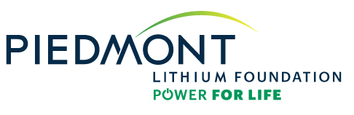

Education Grant Application Form
Fall 2023

Grant must include:
- Completed application form
- Budget with an itemized invoice or estimate cost

Eligibility criteria:
- The applicant must be affiliated with an academic institution that has a connection to the communities where we plan to operate in McMinn County, Tennessee and Gaston County, North Carolina.
- The funding is expected to support educational activities or improve access to STEM-based learning programs in K-12 or post-secondary schools.

Additional items to consider:
- Only proposals made on the current application form will be considered.
- Applicants requesting more than $10,000 may be asked to make a presentation to the Piedmont Lithium Foundation Board of Directors.
- Please complete the application in its entirety. Incomplete applications will not be accepted. The deadline for this application to be received is June 30, 2023.

Grant Application Form
Fall 2023

The Piedmont Lithium Power for Life Foundation intends to support educational needs of local schools and educators to further the success of students in science, technology, engineering, and math fields. We are pleased to support these efforts with monies to make supplies available, to support educational activities (i.e., participation in STEM competitions, purchasing educational materials, etc.), and otherwise improve access to STEM education for NC and TN students. Please submit a project proposal which helps the Power for Life Foundation to further this objective.

Project Title:

Requesting Person/Group:

Email Address:

Amount Requested:

BRIEF SUMMARY OF NEED/REQUEST FOR FUNDS:

Please answer the following questions.
- What problems or needs will this project address, and what are your goals? How was the need determined?

- Describe the effect of this project?

- How many students will be impacted per school year?

- Is this a first-time request? If not, how many times have you requested funds for this project? Why is there a continued need for this project?

- Are you seeking other funds? If so, from what sources?

- How will this project be evaluated for effectiveness?

7. Briefly share other information you feel is relevant to our consideration of this request?

Applicant signature: By typing full name and date, I certify that all the information I have provided in this application is complete and truthful to the best of my knowledge.

Signature:

FOR FOUNDATION USE ONLY:
Date received _________________________ Recommend to Board: Yes or No
Amount Recommended _________________

